# QGIS (Quantum Geographic Information System)

Step 1: Download QGIS software

Use the given url to download the latest version of QGIS

<https://qgis.org/en/site/forusers/download.html>

choose the QGIS installer as per your device i.e., Windows/macOS/Linux

Step 2: Adding Google Maps to QGIS

* In Browser Panel > XYZ Tiles, right click on “XYZ Tiles” select “New Connection”

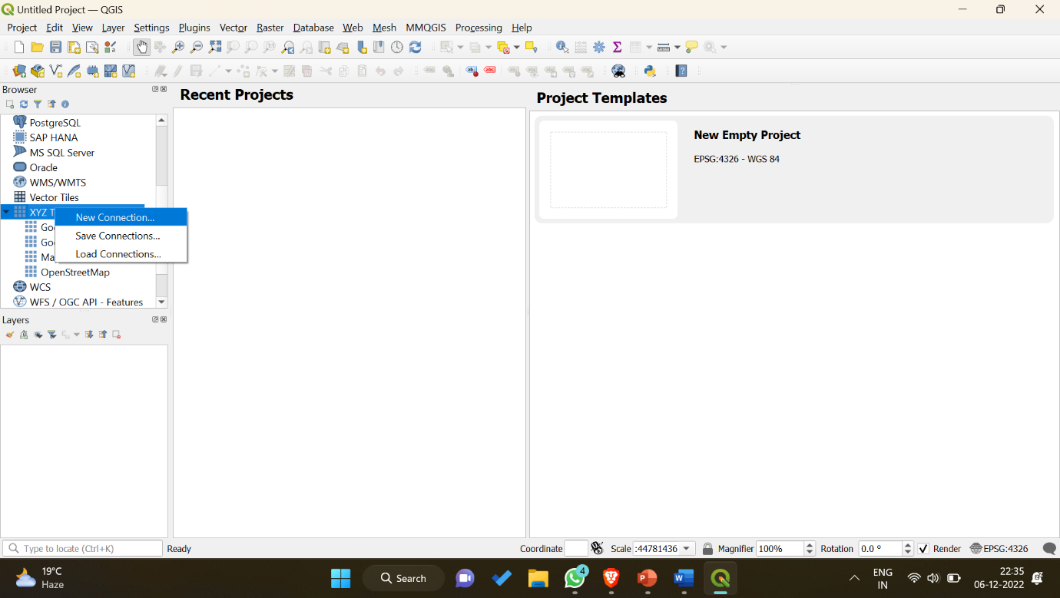

* Enter some name and paste the Google Maps URL which we want to add to QGIS.

Name: Google Maps Satellite View

URL: [https://mt1.google.com/vt/lyrs=y&x={x}&y={y}&z={z}](https://mt1.google.com/vt/lyrs=y&x=%7bx%7d&y=%7by%7d&z=%7bz%7d)

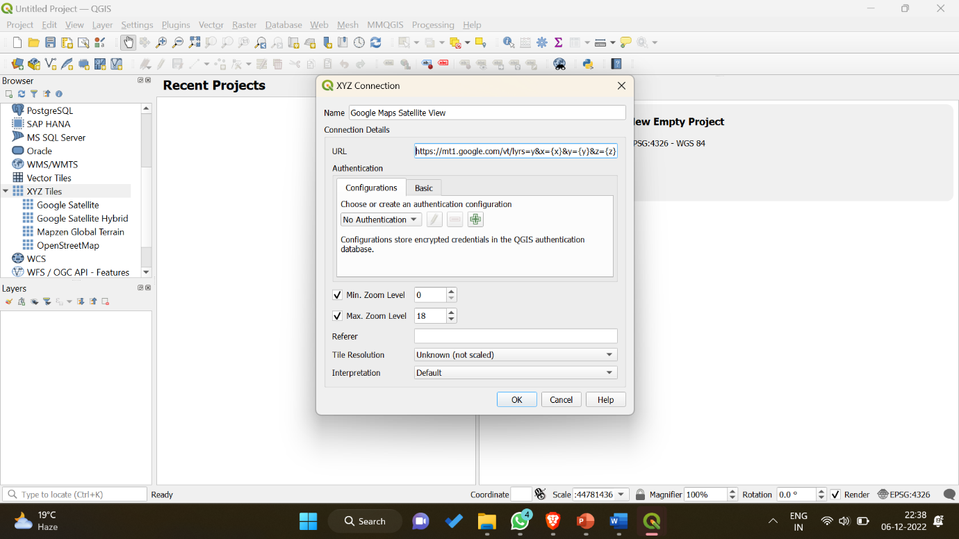

* Click OK, you will see a new field inside Browser Panel > XYZ Tiles > Google Maps Satellite View

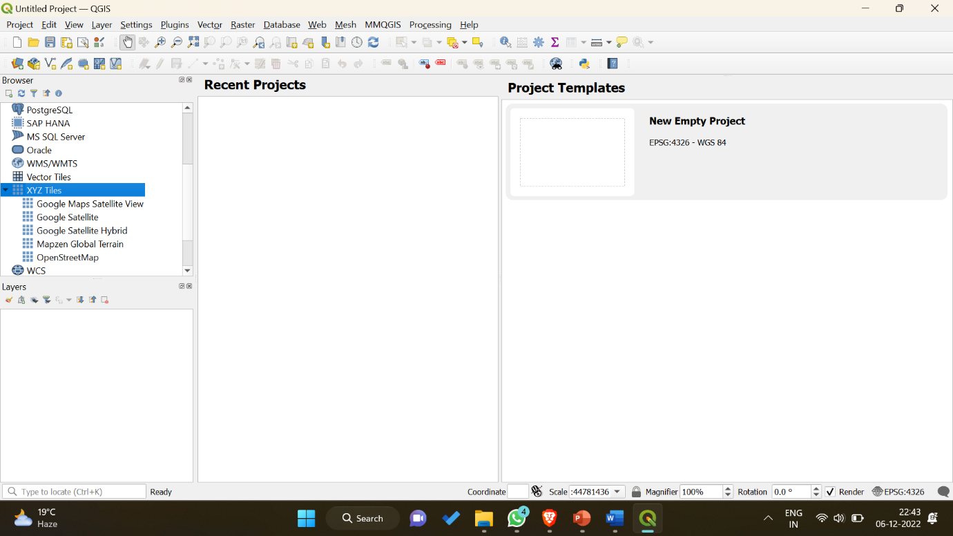

Step 3: Creating a Polygon at our area of interest

* Double click on the Tile which you have created recently. You will be able to see the satellite view of Google Map.
* Navigate to the location you want to mark a polygon/shape using simple zoom in/out.

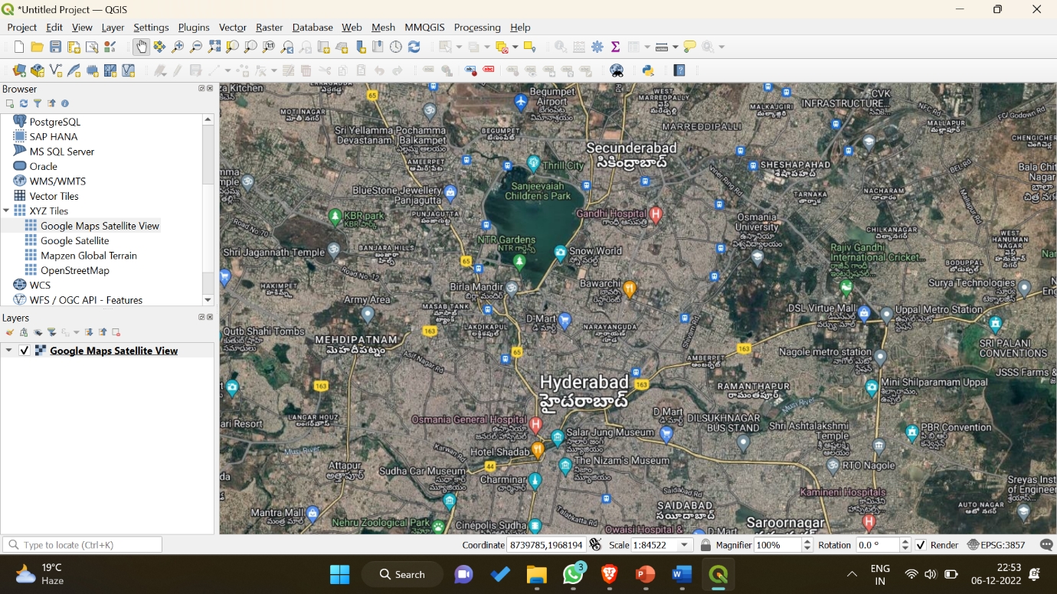

* From the tool bar on top, navigate to Layer > Create Layer and select “New Shapefile Layer”.

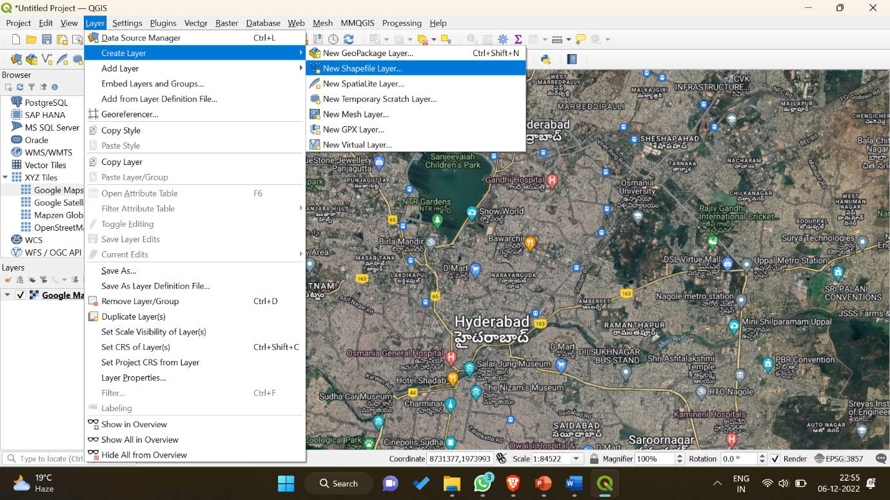

* Enter some name to the shapefile. Then select Geometry Type as “Polygon” from the dropdown, and press OK.

File name: TankBund_Area (Note: donot append .shp to file name, it will automatically add after selecting Geometry type)

Geometry type: Polygon

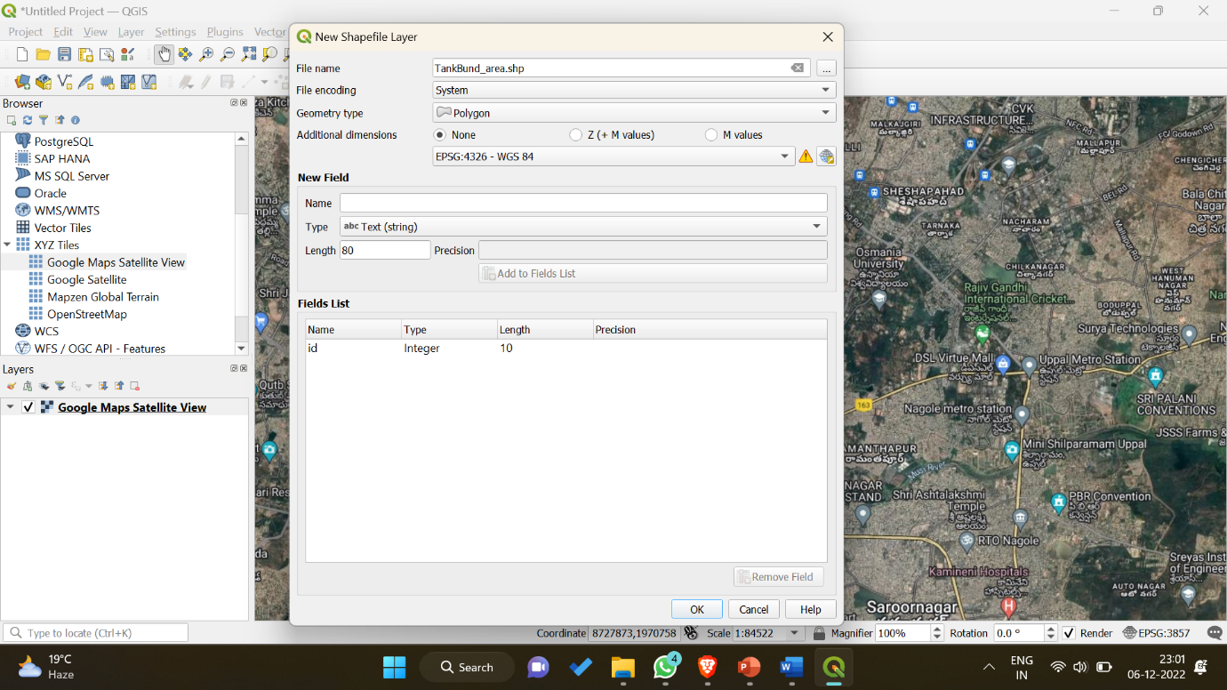

* You will see a new layer is been added to the existing one in the Layers panel.

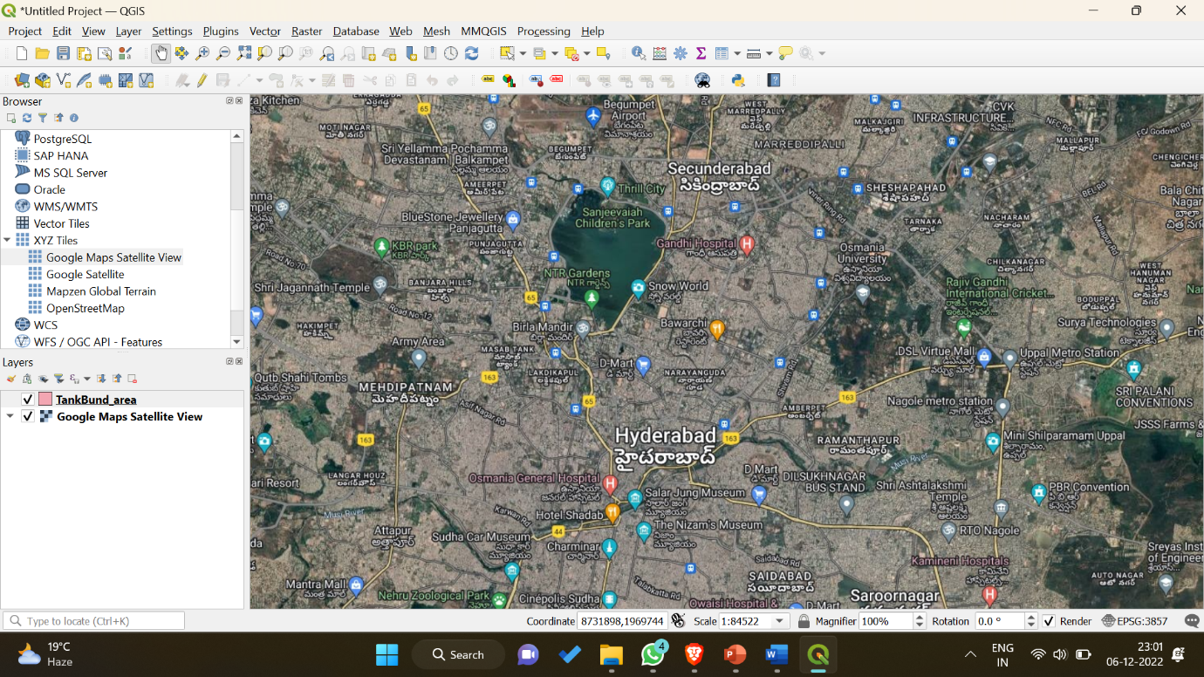

* In the third tool bar click on Yellow Pencil Icon which is a “Toggle Editing”.
* Select an icon 3rd to the Toggle Editing icon in the same row (or) press “ctrl+.”
* Now select the area of interest using left click and when done click right click. Give a number when asked for id in the pop-up.
* Right click on the polygon area layer in layers panel. And navigate to Layers > TankBund_area > Export and select “Save feature as..”

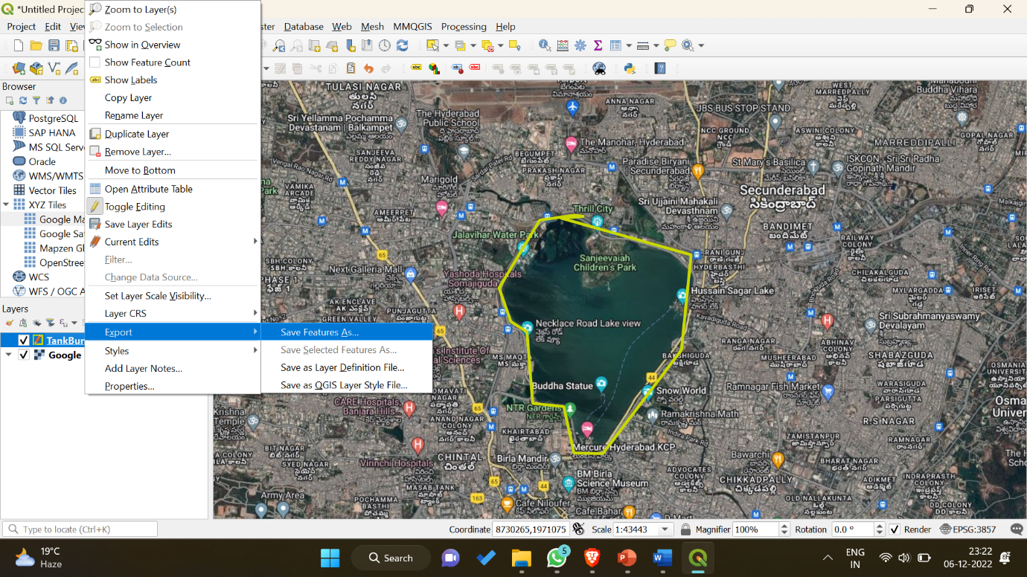

* Enter shape file name to save as some format. In the format select any of the format required from the drop down.

Format: ESRI Shapefile

File name: tankbundarea

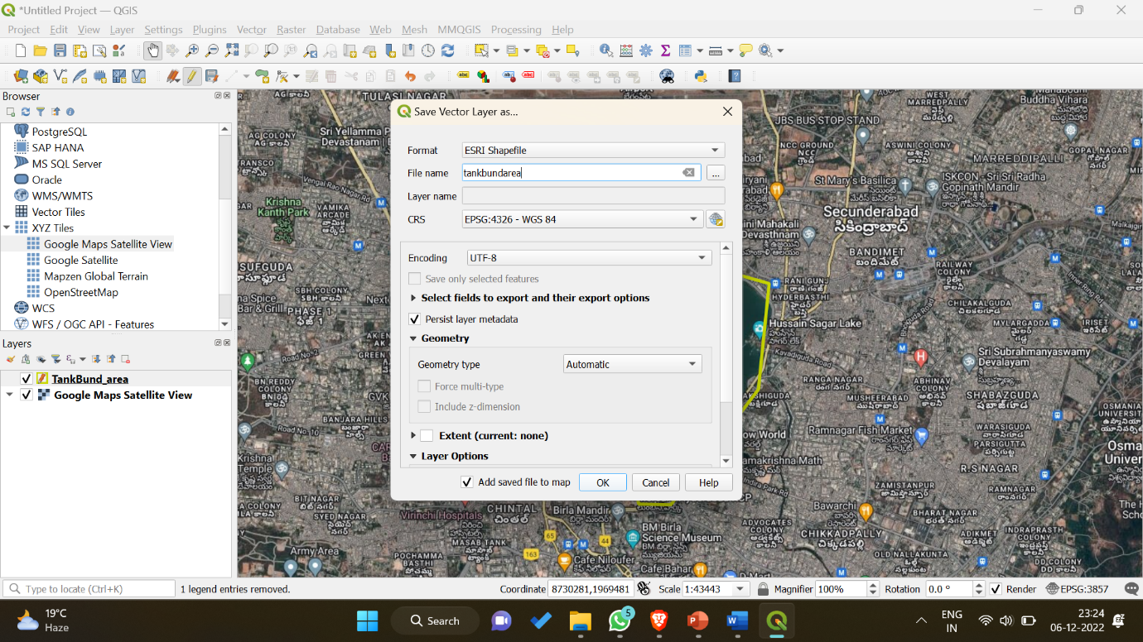

* Click OK. You will see a success message on top and new layer will be added on top of existing ones.

TODO:

Step 4: Adding Satellite Orbit track to QGIS

Step 5: Show the details at which time the satellite will cover our area of interest polygon.